our ref


Grafton House
15-17 Russell Road
Ipswich Suffolk
IP1 2DE

www.ipswich.gov.uk

your ref
please ask for
direct dial 01473 433402
email

Dear Applicant

RE: Licensing Enforcement Officer Post Ref: 2080

Thank you for your interest in the above post. Please find enclosed in this application pack the following documents:

- Job Description
- Person Specification

Application Form:
The application form plays a key part in our selection process. We use the information you provide to shortlist for interview.

You are urged to ensure that all the information contained in your application is relevant and that you demonstrate how you meet the criteria on the person specification. Please use the person specification for guidance when filling in the application form.

References: If successful at interview, Ipswich Borough Council will seek to obtain two employment references. Wherever possible the name of your first referee must be from current employment/education and the second from either current or former employment/education. If you cannot provide an “employment” reference please contact the HR Team at Ipswich Borough Council for further assistance.
If you have any recruitment queries, please do not hesitate to contact us on 01473 433402. Please leave your name, number and brief details of your question and a member of the recruitment team will call you back.



Ipswich Borough Council
Job Description: E66

Licensing Enforcement Officer

Main Purpose of Job

To investigate and where necessary, take enforcement action to secure compliance with licences issued by the Council, in accordance with current licensing policy, legislation and guidance.

Main Duties

- To carry out inspections to ensure that persons and premises that hold a licence are acting in compliance with terms and conditions contained therein. This involves regular evening and weekend working. To identify persons and premises which should be licensed but which are not currently licensed and encourage their application for the same. To respond to information received from colleagues, or to complaints made by all stakeholders in and outside of the Council (eg Fire and Police colleagues) in relation to licensed premises/persons.

- To initiate and progress enforcement action where necessary to secure compliance with current policy, legislation and guidance. To prepare enforcement reports for submission to legal services and to prepare legal statements and give evidence, as necessary. To assist colleagues with preparation of the same. Attend Licensing and Regulatory Committee and Magistrates Courts, as necessary, to give evidence to support enforcement casework. To apply own initiative to bring about resolution of conflict, whether by negotiation or enforcement.

- Maintain register of licensed door supervisors and liaise with national organisations regarding its content.

- To negotiate with all stakeholders in relation to licensing matters via personal visits to site, or via correspondence. Attend meetings of local stakeholder representatives, e.g. club business proprietors, Fire and Police, local residents, other IBC officers, local Councillors etc to assist with the dissemination of information amongst all parties. This will also include giving updates on new legislation to licensees as required.

- To obtain, analyse, interpret and apply new legislation in relation to the Council’s licensing functions.

- To accurately maintain relevant electronic and paper-based systems

Such variations as may be required from time to time without changing the general character of the duties shown above or the level of responsibility entailed.

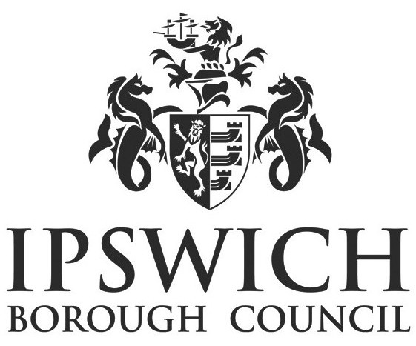 | Ipswich Borough Council  Person Specification  LICENSING ENFORCEMENT OFFICER (E66)
ATTRIBUTES | ESSENTIAL | DESIRABLE | METHOD OF ASSESMENT
Qualifications | 2 A Levels or NVQ Level 4 or have 3 years’ experience including proven level of technical and organisational knowledge and experience in a relevant field such as Licensing or other regulatory activity. | Membership of a relevant professional body such as The Institute of Licensing, CIEH or NALEO. | Sight of certificates
Work related experience / job related skills | Proven experience of working in an investigative / front line enforcement role in Licensing or similar regulatory environment.  Experience of word processing and extracting data from databases. | Experience of Local Authority licensing enforcement across a range of premises/activities.  Knowledge of Health and Safety and ability to carry out risk assessments in relation to own work.  . | Application form / Interview
Other relevant experience | Able to demonstrate a commitment to continuous personal development. |  | Application form /interview
Specialist knowledge | Knowledge of the PACE, and experience of carrying out interviews under caution and the preparation of prosecution files.  Awareness of all licences/approvals issued and enforced by Local Authorities | Detailed knowledge of:  Taxi/hackney carriage licensing, Licensing Act 2003, Gambling Act 2005, animal welfare licences etc. | Application form / Interview
Job Related Skills | Good both verbal and written  communication skills  Able to prepare statements, reports and letters within deadlines.  Able to work on own initiative as well as part of a team;  Ability to keep and maintain accurate and up to date records; | Ability to advise others on policies and procedures. | Application form / Interview
Personal skills | Good customer care skills; Able listen to and understand customer complaints / enquiries.  Ability to remain calm and controlled in confrontational situations.  Ability to communicate with people of all levels and external organisations. | Experience of producing material in ‘plain English’ and in assisting people who do not have English as a first language. | Application form / Interview
Specialist working conditions | Willing to work outside of normal working hours, including evening and weekends on a regular basis.  Ability to patrol the town and make visits to taxi ranks / operators, licensed premises etc. |  | Application form / Interview

