Stoke Park and Chantry Neighbourhood Board
Minutes, Decisions Taken & Action Points

Date: | Tuesday 15 September
Time: | 16:30 – 18:00
Venue: | Paul's Social Club
Members: | Aaron Morley  Abi Abidoye  Cllr Chu Man (representing the Ward Councillors)  Emily Swinerd  John North  Jon Reynolds  Kerry Hawes  Lee Walker (Chair)  Teresa Davidson
Apologies: | Peter Mower  Jack Abbott MP
Other Attendees: | Kate Price, Assistant Director – Communities  Laura Meadows, Pride in Place Programme Manager

MINUTES
1. | Welcome and Apologies for Absence  Lee Walker (LW) welcomed the group and provided Apologies for Absence from Peter Mower and Jack Abbott MP.
2. | Declarations of Interest  Cllr Chu Man (CM) declared an interest in Agenda Item 5, as marketing falls within his professional area of expertise.
3. | Minutes of the Previous Meeting and Update on Action Points  The group approved the minutes of the previous meeting. LW provided an update on the outstanding action points.
  Action Point | Status
  All members to start considering who else could be involved in the programme and consulting with the local community. LW to contact organisations and groups that could support the initiative and encourage them to begin thinking about how they might contribute. | In progress
  LM to share the findings from the Community Action Suffolk (CAS) VCFSE engagement workshop when available. | Complete
  LM to circulate a skills audit to identify existing knowledge and experience within the Neighbourhood Board, as well as the Board's strengths and any gaps in skills, expertise or representation. | Complete
  LW to set up a WhatsApp group for Neighbourhood Board members. | Complete
  CM to circulate list of feedback from local residents with LM to share with the minutes. | Complete
4. | Interactive workshop: Reviewing local insight and identifying priorities  LW introduced the session as an opportunity to review the local insight collated to date, including feedback from resident engagement surveys conducted by Volunteering Matters, an overview of findings from the VCFSE workshops facilitated by Community Action Suffolk (CAS), and Suffolk Observatory data relating to Stoke Park and Chantry. LW explained that the purpose of the workshop was to review the evidence gathered to date, begin identifying key priorities for Stoke Park & Chantry, and discuss approaches to ongoing resident engagement. The aim was to ensure that the Pride in Place programme remains community-led and reflects the issues and opportunities that matter most to local people.  The Board split into three groups to review the available data and local insight, considering: What does the evidence tell us? What information is missing or remains uncertain? What might this suggest for the Board’s emerging priorities?  AP1: Laura Meadows (LM) to prepare a summary of the key discussion points and emerging priorities identified through the local insight gathered to date.  After 30 minutes of discussion and break out group activities, the Board came together to share an overview of key findings:  - Jon Reynolds (JR) reported on behalf of the group that reviewed Suffolk Observatory data. The group identified strengths including transport links, health and access to green spaces. Gaps identified included a lack of activities and opportunities for young people. John North (JN) noted some concern about the data relating to violent crime and suggested inviting community policing representatives to a future meeting to provide further context on local crime, safety, and public perceptions. AP2: LW to invite community policing representatives to a future meeting to provide further context on crime, safety, and perceptions of crime within the area.  - Kerry Hawes (KH) provided an overview of the discussion from the group that reviewed resident survey feedback from the work undertaken by Volunteering Matters. The group highlighted that residents value the area's parks and green spaces, local shops, and strong sense of community. Key concerns raised by residents related to the cleanliness and appearance of the area, as well as the quality and availability of facilities within local green spaces.  - Emily Swinerd (ES) shared feedback from the group that reviewed insight gathered through the VCFSE engagement workshop facilitated by Community Action Suffolk. The group reported that local organisations are experiencing challenges recruiting and retaining volunteers, and a shortage of safe community spaces in the area. Organisations also highlighted issues affecting residents, including loneliness, social isolation, and a lack of community cohesion. ES emphasised the need for accessible spaces and opportunities for both younger and older people, alongside a greater focus on skills development, employability, and vocational opportunities for young people. The group also discussed ideas around local residents sharing their skills and knowledge with others to build local capacity and strengthen community connections.  Emerging priorities identified across all three discussion themes included the provision of community spaces, including the potential for a community hub, strengthening community cohesion, improving access to training and education opportunities, and ensuring residents can easily access information about activities, services, and opportunities within the local area.  LW summarised that community infrastructure had been a recurring theme throughout the discussions. It was noted that there can be some confusion between issues that fall within the statutory responsibilities of councils and those that could be addressed through the Pride in Place programme. LW highlighted the importance of understanding where the Neighbourhood Board can add value and focus its resources on priorities that are within its remit to influence or deliver.  KH noted the importance of delivering some quick, visible wins to demonstrate progress, build confidence in the programme, and maintain community engagement.  Scans of the worksheets completed during the workshop activities can be found below.  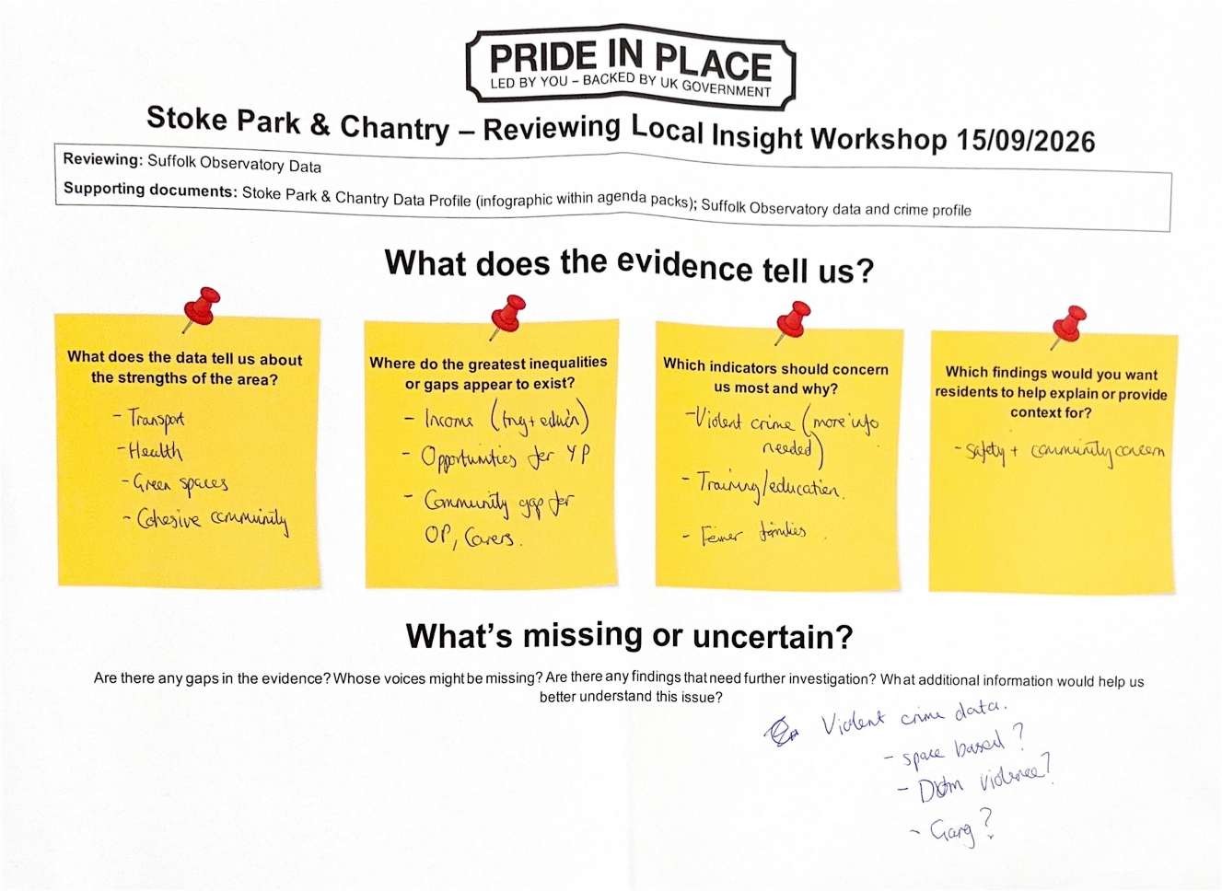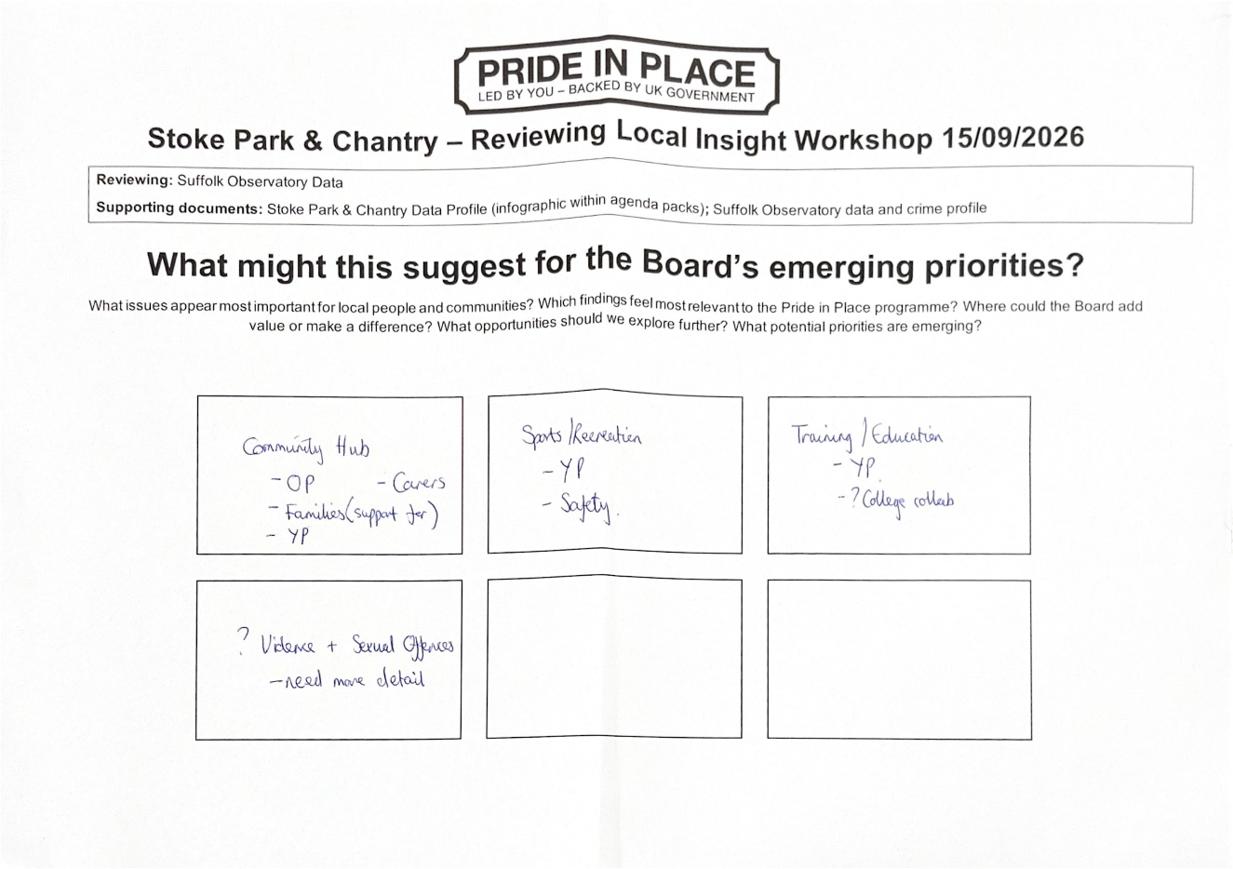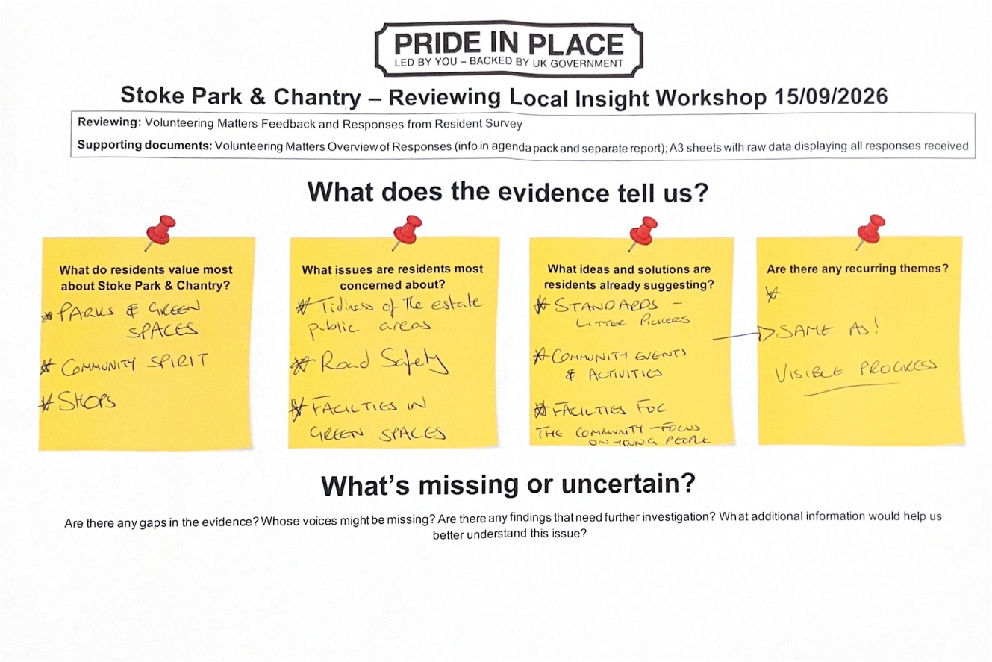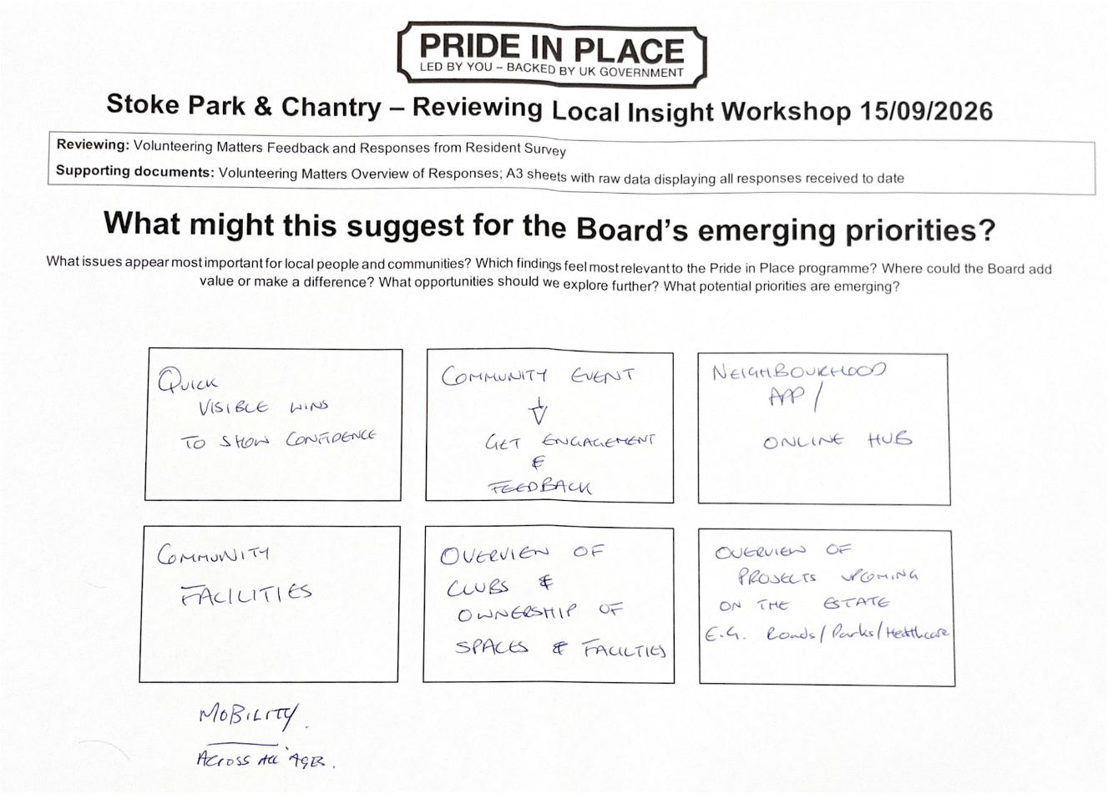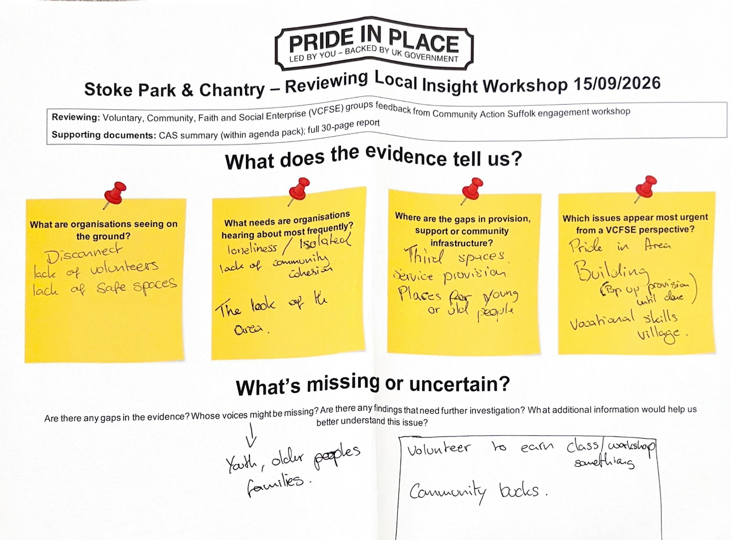  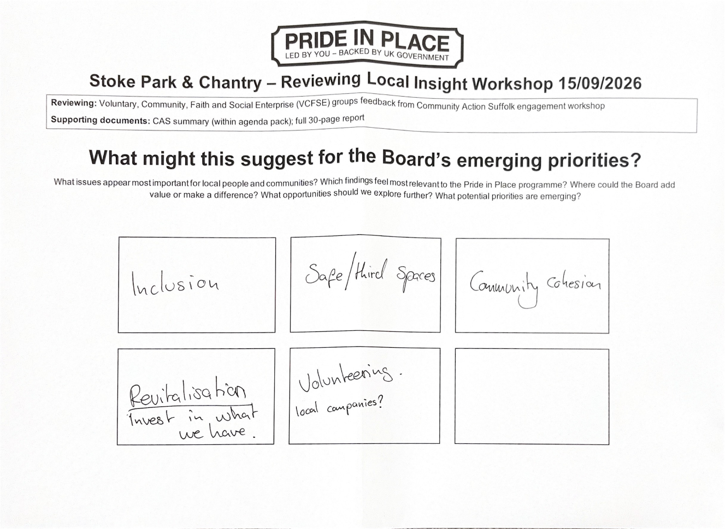
5. | Social media, branding & communications  LW introduced a discussion on communications and branding, seeking the Board's views on the proposed approach between now and Christmas. LW suggested focusing on listening and engagement activity rather than launching significant branding or promotional campaigns at this stage, noting that residents can become frustrated by seeing these types of activities if they are not followed by visible action.  LW provided some options for additional community engagement activities and suggested that external expertise could be beneficial, to complement the Board's local knowledge of the area.  JN supported the use of an external provider but emphasised the importance of providing a clear brief and ensuring an understanding of the geography and characteristics of Stoke Park and Chantry. LW confirmed that regular review meetings would be held with any providers and that all Board members would be invited to participate.  ES asked whether the Board should establish a process or policy relating to expenditure and decision-making. Kate Price (KP) advised that, while Ipswich Borough Council remains the Accountable Body for the programme, any expenditure would be subject to the Council’s financial regulations and governance procedures.  AP3: LW to prepare a specification for community engagement support and circulate the information to Board members for consideration.  LW also explained that he sits on the Creative People and Places Board, which also has funding available within Stoke Park and Chantry. He noted that residents may become confused by multiple programmes operating in the area and suggested exploring how the two programmes would work together, for example through shared communications platforms and resources, helping to keep messaging clear and consistent. AP4: LW to circulate further information to Board members on the Creative People and Places programme, including the proposed branding and communications approach.  The group discussed the draft concept branding developed by Volunteering Matters. Members felt that the location shown within the imagery was difficult to interpret and did not clearly represent the whole programme area, particularly Stoke Park. It was suggested that recognisable local landmarks, such as Bourne Park, could be considered within future designs.  JN commented that he was uncertain about the Volunteering Matters branding and some of the engagement activity undertaken to date. LW explained that this work was commissioned prior to the establishment of the Neighbourhood Board to gather initial community insight and that future decisions would be led by the Board.  LW asked members whether they wished to develop a standalone identity for the programme or align with a broader community brand. CM suggested developing a Stoke Park and Chantry brand that could continue beyond the lifespan of Pride in Place, with Pride in Place acting as the mechanism to support its development. He envisaged a lasting community resource that could provide information and signposting for residents.  Laura Meadows (LM) highlighted a potential risk associated with aligning the Pride in Place branding too closely with other community initiatives. LM noted that Pride in Place is a long-term, ten-year programme, and questioned how branding linked to shorter-term projects would be managed if those programmes were to end in the future.  The group agreed that any branding approach should consider long-term sustainability and ensure a simple, accessible, clear, enduring identity for the programme. LW indicated that he would draft a short branding brief, supported by CM, and would seek to build on the engagement work already undertaken by Volunteering Matters where appropriate. AP5: LW and CM to develop a branding brief for the Stoke Park & Chantry Pride in Place area, reflecting Board feedback and setting out key principles, themes and requirements for future branding and communications.  It was noted that the aim was to create a recognisable identity for the area, rather than simply using photographs of existing local landmarks. Teresa Davidson (TD) suggested the use of a symbol or emblem, with LW citing the Manchester bee as an example of a successful place-based identity.  AP6: LW to arrange a meeting for Board members interested in marketing and communications to discuss and progress the next steps.  AP7: CM to develop some initial branding concepts for consideration, based on the theme of "Stoke Park & Chantry, powered by Pride in Place".
6. | Future meetings  The group discussed the scheduling of future Board meetings and recognised that not all members were available on the same day and time. To support attendance and ensure fairness, it was agreed that meetings would alternate between Tuesday and Thursday evenings.  The group agreed that Tuesday meetings would be held from 5.30pm to 7.00pm, while Thursday meetings would take place from 4.30pm to 6.00pm.  LW highlighted a preference for meetings to be held in person, but confirmed that a Microsoft Teams link could be provided where appropriate to support attendance.
7. | Any Other Business (AOB)  ES provided an update following a meeting with representatives from Sanctuary Housing and Suffolk New College. Discussions included the planning of a stakeholder event held at St Peter’s Church, where a range of organisations will be represented. ES noted that there are many free courses and support opportunities available that are currently underutilised by local residents, and highlighted the potential value of engaging a wider range of stakeholders in the area, including organisations such as Citizens Advice.  ES suggested using the event as an opportunity to raise awareness of Pride in Place amongst partner organisations and explore how they could become involved in supporting delivery of local priorities. ES also suggested that a small fund could be made available to support pilot activities and test different approaches to community engagement and participation.  LM shared that other Pride in Place areas are doing similar work, launching small grant funding pots to enable some quick wins to take place. LM recommended undertaking this work once local priorities have been agreed and the Pride in Place Plan has been completed, so the grant funding and any projects funded are directly linked to the Board’s priorities. LW suggested that a small community grants programme could be explored in January, potentially alongside the launch of the area's branding and identity.
DATE OF NEXT MEETING
Thursday 15 October, 4.30pm to 6.00pm. The venue is to be confirmed. While attendance in person is encouraged, a Microsoft Teams link will be made available for members who are unable to attend in person.

Future meeting dates:
- Tuesday 10 November 2026, 5.30 – 7.00pm
- Thursday 10 December 2026, 4.30 – 6.00pm
- Tuesday 12 January 2027, 5.30 – 7.00pm
- Thursday 11 February 2027, 4.30 – 6.00pm

DECISIONS TAKEN
- Future meetings will alternate between Tuesday and Thursday evenings.

ACTION POINTS
- AP1: Laura Meadows (LM) to prepare a summary of the key discussion points and emerging priorities identified through the local insight gathered to date.
- AP2: LW to invite community policing representatives to a future meeting to provide further context on crime, safety, and perceptions of crime within the area.
- AP3: LW to prepare a specification for community engagement support and circulate the information to Board members for consideration.
- AP4: LW to circulate further information to Board members regarding the Creative People and Places branding approach.
- AP5: LW and CM to develop a branding brief for the Stoke Park & Chantry Pride in Place area, reflecting Board feedback and setting out key principles, themes and requirements for future branding and communications.
- AP6: LW to arrange a meeting for Board members interested in marketing and communications to discuss and progress the next steps.
- AP7: CM to develop some initial branding concepts for consideration, based on the theme of "Stoke Park & Chantry, powered by Pride in Place".

