Stoke Park and Chantry Neighbourhood Board
15 September 2026 – Workshop Analysis

Context
As part of the Neighbourhood Board meeting, Board members were split into three groups, with each group reviewing a different source of data or community insight. This included demographic and socio-economic data from the Suffolk Observatory relating to the Stoke Park & Chantry area, resident survey feedback, and insight gathered from Voluntary, Community, Faith and Social Enterprise (VCFSE) organisations.

Each group was given 30 minutes to explore and discuss their allocated evidence source, considering the following questions:
- What does the evidence tell us?
- What is missing, unclear, or uncertain?
- What might this suggest about the Board's emerging priorities?

Following the group discussions, members reconvened for a sharing session to discuss reflections and consider the next steps. This focused on identifying what additional evidence, insight, and community engagement activity may be required to help inform and agree the emerging priorities for the area.

Review of Stoke Park & Chantry data from Suffolk Observatory
Discussions on the Suffolk Observatory data focused on both the area's strengths and the challenges revealed through the evidence. Board Members recognised a number of positive aspects of Stoke Park and Chantry, including transport links, green spaces and indicators suggesting strong community spirit. However, concerns were raised regarding health inequalities, educational attainment, training opportunities and the availability of opportunities for young people. There was also discussion about gaps in support for older people, carers and families, with Board Members feeling these groups may require extra support.

A significant proportion of the discussion centred on understanding the context behind the data. Board Members felt that some indicators, particularly those relating to income, education and crime, would benefit from further explanation from residents themselves. Violent crime data generated considerable debate, with attendees questioning whether incidents were linked to specific locations, domestic circumstances or wider community issues. The group agreed that crime statistics alone do not tell the full story and that additional engagement is needed to understand how residents perceive safety and what factors may be contributing to the figures.

In exploring potential priorities, Board Members discussed the development of a community hub as a possible solution to several identified issues, including support for young people, families, carers and older residents. There was also strong support for sports and recreational opportunities for young people, alongside a focus on education, skills and training. Suggestions included exploring partnerships with colleges and training providers to improve access to opportunities. Safety remained an important discussion point, with Board Members noting that more detailed evidence would be required before identifying specific actions.

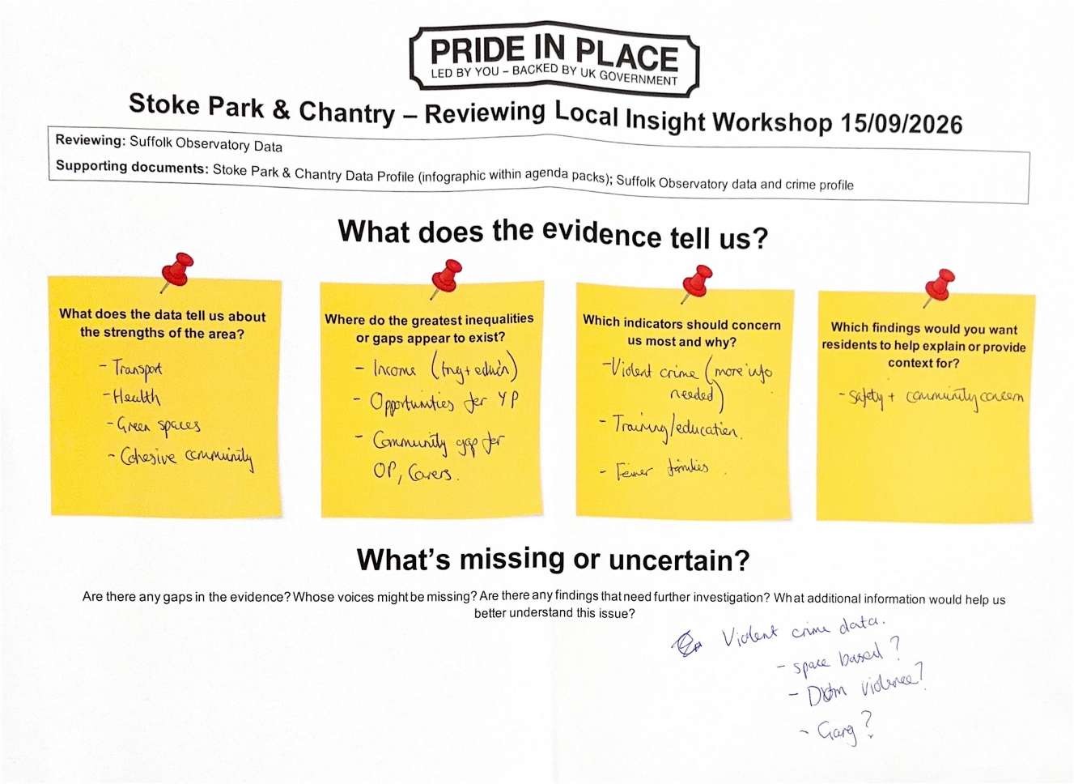
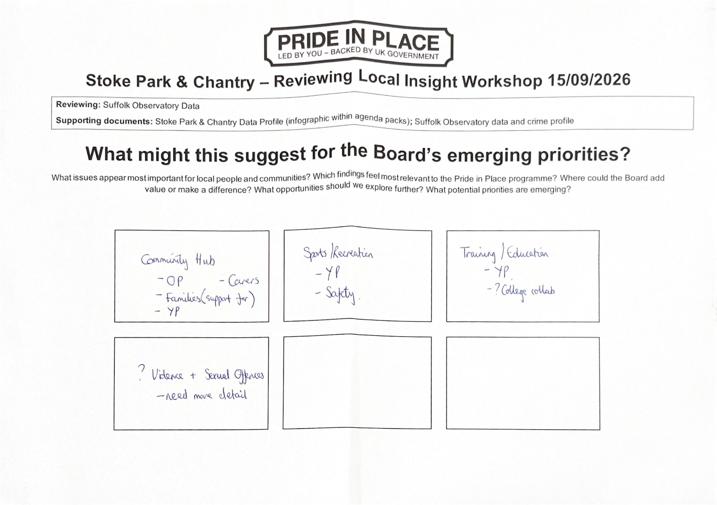

Review of feedback from local residents – residents survey conducted by Volunteering Matters
Discussion of the resident survey feedback highlighted a number of strengths that residents value about Stoke Park and Chantry. Parks and green spaces were consistently recognised as important local assets, alongside local shops and a strong sense of community spirit. Board Members felt these positive aspects provide a strong foundation on which the Pride in Place programme can build. Residents demonstrated affection for their local area and a desire to see it continue to improve.

Residents' concerns focused largely on the physical environment and quality of place. Issues such as litter, the tidiness of public areas and road safety were raised regularly. The survey responses also demonstrated a desire for greater investment in community facilities, particularly facilities for young people. Suggestions from residents included community-led litter picking activities, improvements to parks and green spaces, community events and activities, and projects that would create visible improvements within the neighbourhood. Board Members noted that residents wanted to see tangible changes that demonstrate progress and build confidence in the Pride in Place Programme.

The group identified several possible priorities arising from the resident feedback. There was support for achieving some quick, visible wins that would demonstrate positive change, alongside longer-term improvements to community facilities and public spaces. Board Members also discussed opportunities to improve communication and engagement through an online hub or neighbourhood app, allowing residents to find information about local clubs, activities and upcoming projects. Improving awareness of community assets and encouraging greater community ownership of local spaces were seen as important opportunities to strengthen pride in place and increase participation across all age groups.

The group were keen to learn more through additional community engagement activities.

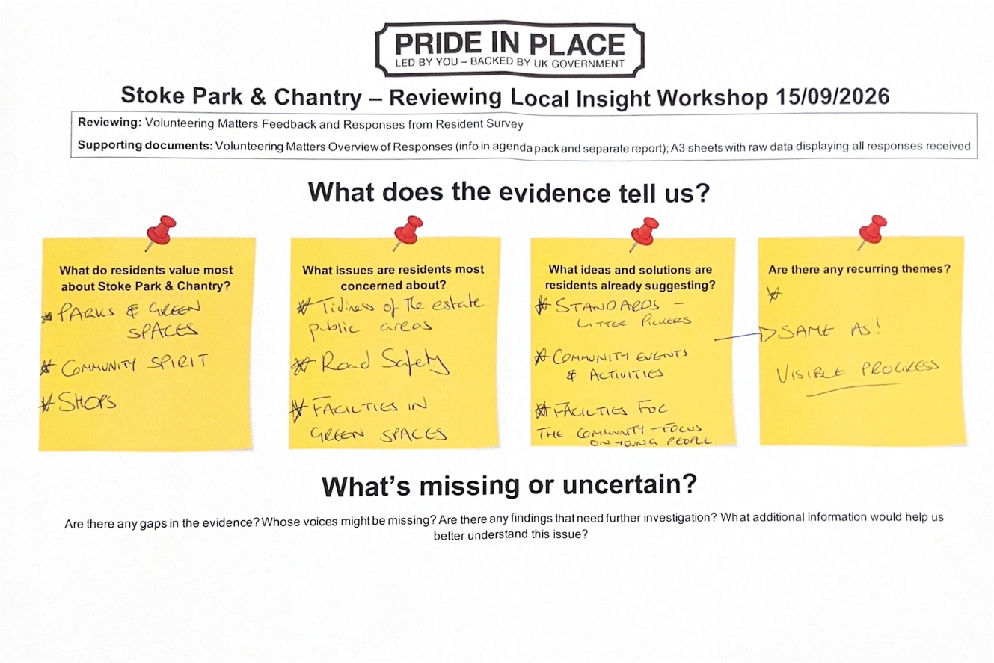

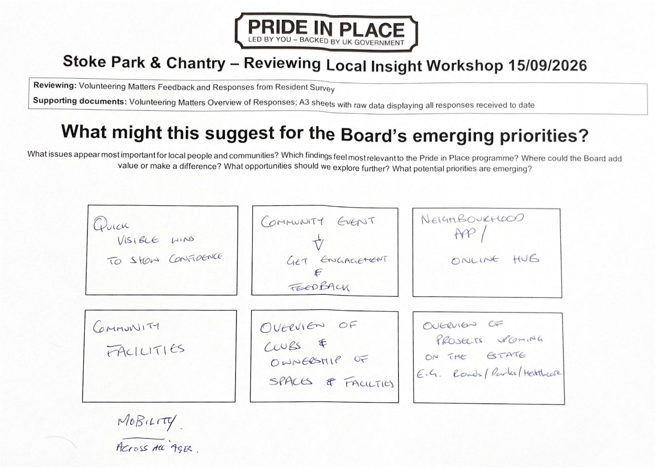

Review of local insight from Voluntary, Community, Faith and Social Enterprise (VCFSE) groups operating in Stoke Park & Chantry – insight provided by Community Action Suffolk
Discussion of the VCFSE feedback focused largely on what local organisations are experiencing on the ground within Stoke Park and Chantry. Board Members highlighted concerns about social disconnection, loneliness and isolation, alongside a lack of volunteers to sustain local activities and support services. Organisations also reported a shortage of safe and welcoming places where residents can come together, leading to discussion around the importance of community cohesion and strengthening relationships within neighbourhoods. Board Members felt that, despite the presence of community assets, many residents remain disconnected from activities, support networks and opportunities available to them.

The group identified several gaps in community infrastructure, particularly a lack of "third spaces" where people can meet informally outside of home, work or education. Limited provision for young people and older residents was also highlighted, alongside concerns about the availability of local services. Discussions explored how greater pride in the area, improvements to the physical environment, and investment in community buildings or community hubs could help address these issues. There was also significant discussion around vocational skills and opportunities for residents to gain experience, with suggestions such as incentivised volunteering schemes. Board Members felt that youth, older residents and families may be underrepresented within the current evidence base and that further engagement with these groups would be beneficial.

When considering potential priorities, the group identified community cohesion, inclusion, volunteering, safe community spaces and neighbourhood revitalisation as key themes. Board Members felt there was an opportunity to build on existing assets by investing in what already exists, while also exploring how local VCFSE organisations, businesses and employers could contribute to strengthening volunteering and community participation.

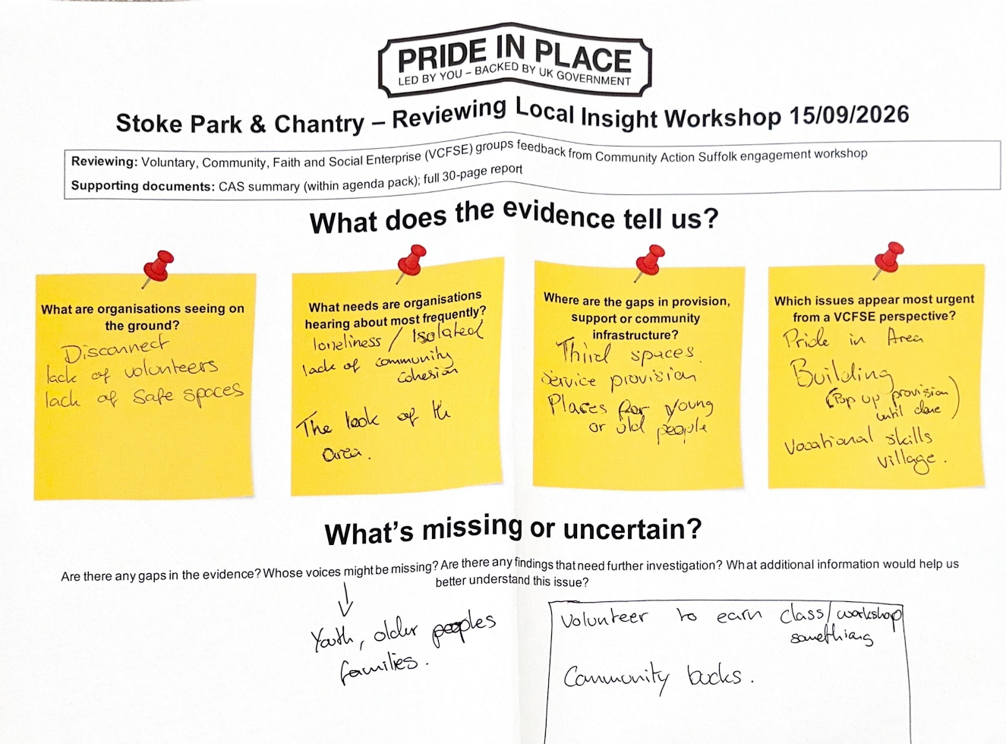

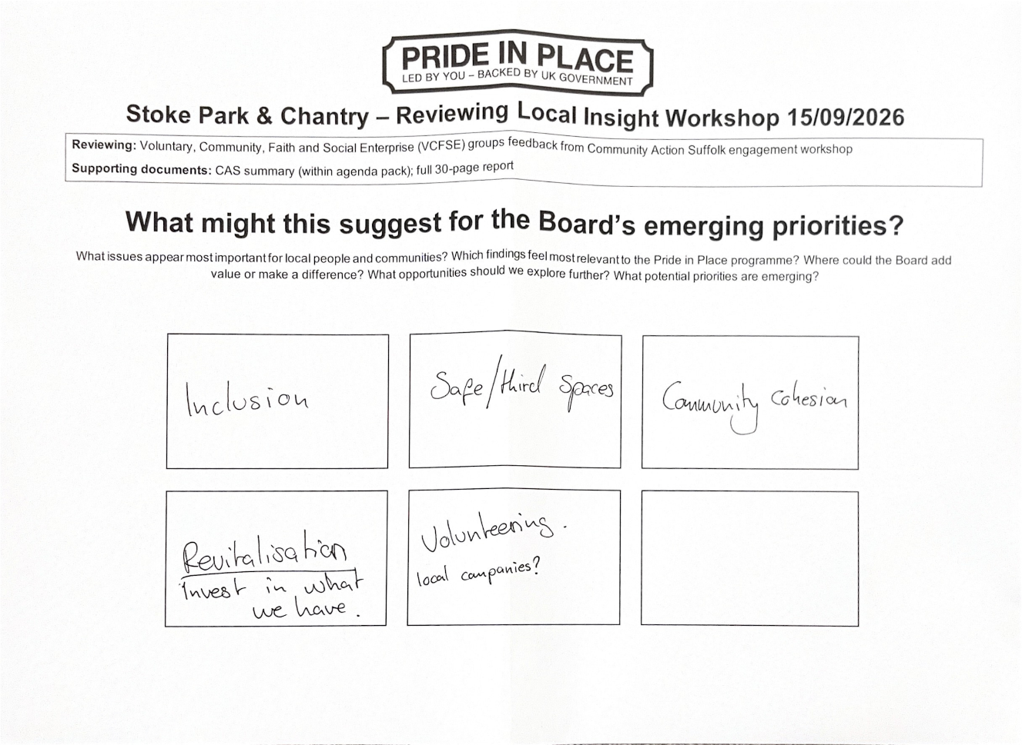

Emerging themes from workshop discussions
Across all three sources, several themes appeared consistently. These included the need for stronger community spaces and infrastructure, greater community cohesion and inclusion, improved opportunities for young people, support for volunteering and community participation, and action to improve the appearance of the local area. There was also a shared recognition that residents need better access to information, opportunities and community networks. Finally, all groups highlighted the importance of gathering further insight, particularly from young people, older residents, families and those whose experiences may not yet be fully represented in the evidence.

Community spaces and infrastructure
A recurring theme across multiple discussions was the need for more accessible community spaces and opportunities for people to come together. Attendees highlighted a lack of "third spaces"; places outside of home and work, education, or other formal settings where residents can meet informally, socialise, build relationships, and participate in community life. Board Members also raised concerns about limited provision for both younger and older people. The idea of developing a community hub was raised repeatedly, with potential benefits for young people, older residents, carers, and families by providing a focal point for activities, support, and community connections.
Workshop Board Members felt that strengthening community infrastructure could help tackle isolation, improve access to support, and increase opportunities for local activities and services.

Community cohesion and social connection
Board Members identified loneliness, isolation, a lack of community connection, and the need for greater inclusion as significant issues affecting local people. Organisations working in the area reported concerns about disconnect between residents and a lack of opportunities for meaningful community interaction. Community spirit was also highlighted as one of the area's strengths, suggesting there is an opportunity to build upon existing goodwill and resident pride.
Possible priorities could include community events, volunteering opportunities, activities that bring different groups together, and initiatives that encourage residents to feel more connected to their neighbourhood.

Pride in Place and improving the local environment
Residents consistently identified parks, green spaces, local shops, and community spirit as valued aspects of the area. At the same time, concerns were raised regarding the tidiness and appearance of public spaces, including litter and estate maintenance. Workshop Board Members discussed the importance of visible improvements that demonstrate positive change and help build confidence in the programme.
There was strong support for initiatives such as litter-picking, environmental improvements, enhancements to parks and green spaces, and projects that encourage greater community ownership of local assets.

Opportunities and support for young people
Young people were repeatedly identified as a group requiring greater focus. Board Members highlighted a shortage of activities, facilities, and opportunities available to young people locally. Concerns were also raised regarding education, training opportunities, and pathways into employment.
Potential areas for further exploration include youth activities, sports and recreation opportunities, partnerships with local education providers, vocational skills development, and improving access to training and employment support.

Information sharing and resident engagement
Workshop Board Members recognised the importance of improving communication with residents. Suggestions included developing online community platforms, creating better visibility of local clubs and activities, sharing information about ongoing projects, and establishing clearer feedback mechanisms so residents can see how their views influence decision-making.
Improved communication could help strengthen engagement, increase awareness of local opportunities, and support greater community participation.

Next steps
Following the workshop and the discussions that took place, the Board agreed that further community engagement should be undertaken to explore the emerging themes in more detail and help determine which should be prioritised through the Pride in Place programme.
Board members recognised that the workshop had identified a number of recurring issues and opportunities across the different evidence sources. However, additional engagement with residents and stakeholders will be important to test these findings, gather further views, and ensure that future priorities reflect the needs and aspirations of the wider community.
It was also noted that some of the topics raised during the workshop, particularly around crime and community safety, may fall primarily within the responsibilities of statutory agencies and partner organisations. While these issues are important to residents, they may sit outside the direct remit of Pride in Place. As a result, the programme's role and funding are likely to focus on supporting complementary community-led initiatives, strengthening local partnerships, and advocating for residents' concerns where appropriate, rather than directly delivering services that are the responsibility of statutory organisations.
The analysis from the workshop has been shared with Board members and provides a good evidence base to support the next phase of engagement and the development of priorities for the Stoke Park & Chantry Pride in Place Plan.

