Whitehouse Neighbourhood Board
7 October 2026 – Workshop Analysis

Context
As part of the Neighbourhood Board meeting, Board members were split into four groups, with each group reviewing a different source of data or community insight. This included demographic and socio-economic data from the Suffolk Observatory relating to the Whitehouse Ward, resident survey feedback, insight gathered from Voluntary, Community, Faith and Social Enterprise (VCFSE) organisations, and discussion points from a recent youth hack at Westbourne Academy, conducted by Volunteering Matters.

Each group was given 25 minutes to explore and discuss their allocated evidence source, considering the following questions:
- What does the evidence tell us?
- What is missing, unclear, or uncertain?
- What might this suggest about the Board's emerging priorities?

Following the group discussions, members reconvened to share their key findings and reflections from the evidence reviewed. Through these discussions, Board Members considered what the data, resident feedback and stakeholder insight revealed about Whitehouse, identified gaps in the current evidence base, and began exploring how these findings could help shape future priorities for the Whitehouse Pride in Place Programme.

Review of Whitehouse data from Suffolk Observatory
Discussion of the Suffolk Observatory data highlighted a number of positive indicators within Whitehouse. Board Members noted strong educational attainment amongst younger people for Level 1 & 2 qualifications compared to national averages, alongside higher rates of apprenticeships and evidence that many residents both live and work locally. Good transport connections, positive perceptions of health and higher levels of active travel, including walking to work, were also recognised as strengths, demonstrating that a significant proportion of residents live and work in Whitehouse.

At the same time, Board Members identified several areas of concern. Despite some positive educational outcomes at Level 1 & 2 qualification level, there appeared to be a significant proportion of residents with no qualifications (just under ¼, 24.6% of all residents have no qualifications, which is significantly higher than the Suffolk average of 19.7% and national average of 18.1%). There are also lower than the Suffolk and national average of residents obtaining Level 3 or higher qualifications. Members discussed the need to better understand who these residents are and whether there are particular barriers affecting access to education, training or employment opportunities. Concerns were also raised regarding the number of residents who are long-term sick, disabled or have caring responsibilities, alongside questions about health inequalities that may not be immediately visible within headline data.

A key theme throughout the discussion was the need to understand the stories behind the data. Board Members questioned whether some indicators fully reflected local experiences and highlighted several areas requiring further investigation, including health outcomes, qualifications, and economic participation. Members also felt more information was needed about young people who may not be progressing into education, employment or training and whether certain communities were underrepresented within the available evidence.

When considering emerging priorities, discussion focused on supporting young people to achieve positive outcomes in education, employment and training. Board Members also highlighted the importance of sustaining good health and wellbeing across the community, and raising aspirations for all residents, ensuring they can access opportunities throughout their lives.

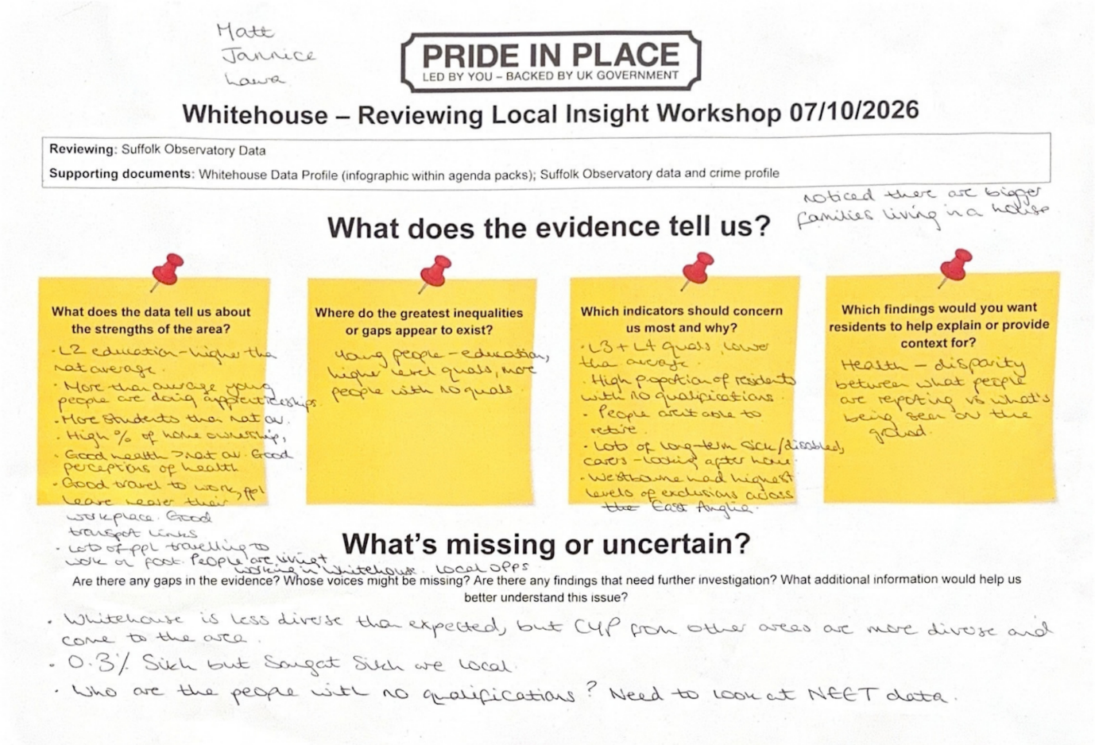

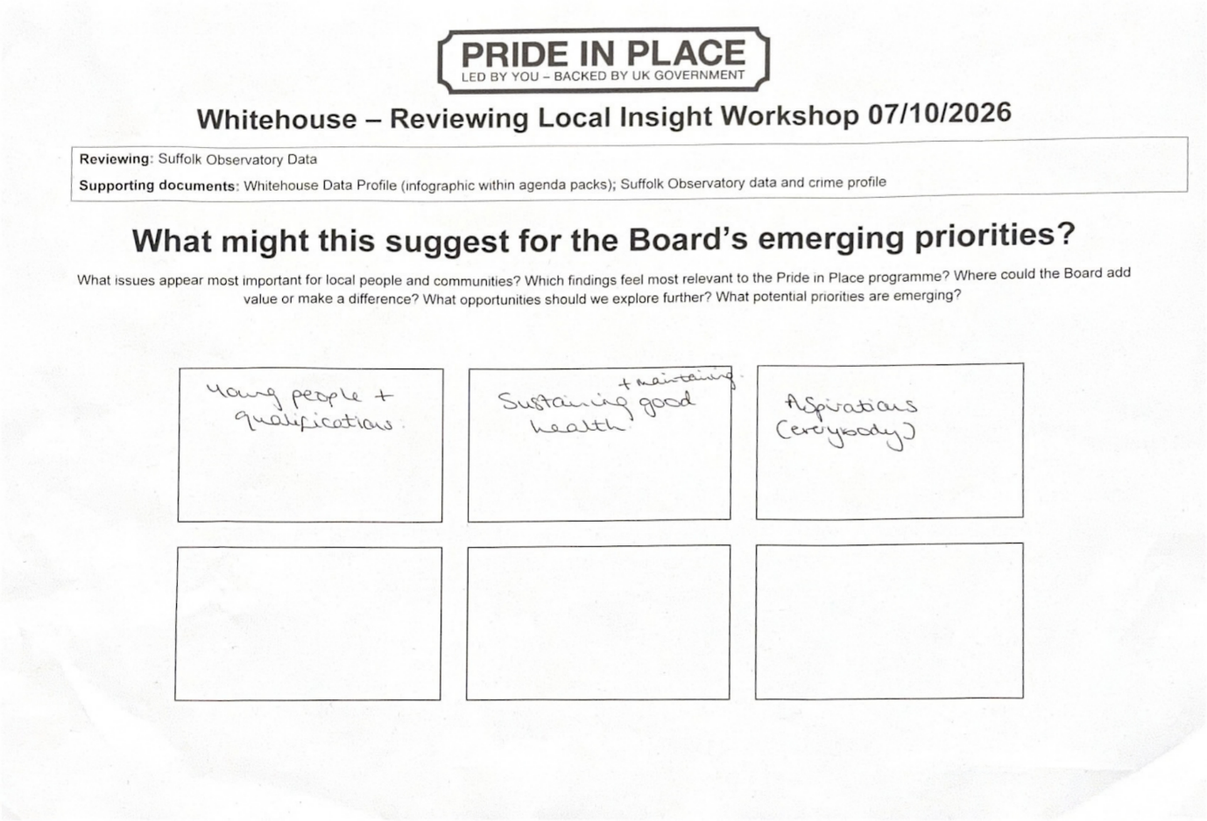

Review of young people's feedback from the Westbourne Academy Youth Hack, conducted by Volunteering Matters
Discussion of the youth engagement findings highlighted a strong appreciation amongst young people for parks, green spaces, local shops and existing social connections within Whitehouse.

However, significant concerns were also identified. Young people consistently reported a lack of activities and facilities available for them locally, particularly opportunities relating to sport, recreation and socialising. Concerns about crime and safety emerged as recurring themes, alongside frustration about litter, the appearance of parts of Whitehouse and the perceived lack of dedicated places for young people to meet.

Young people were already suggesting practical solutions to many of these issues. Ideas included improved parks and play areas, new sports facilities such as football pitches and sports halls, community hubs, employment schemes and a wider variety of local amenities. Many of these suggestions align closely with the objectives of the Pride in Place programme and represent opportunities that the Board can consider.

Potential priorities emerging from the discussion included improvements to parks and public spaces, greater investment in sports and leisure opportunities, development of a community hub or youth-focused space, improving perceptions of safety, and creating pathways into employment for local young people. Board Members also highlighted opportunities to improve the overall appearance of the area.

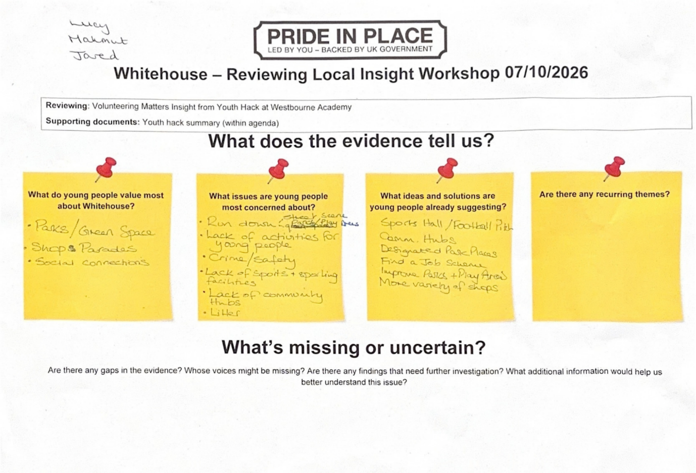
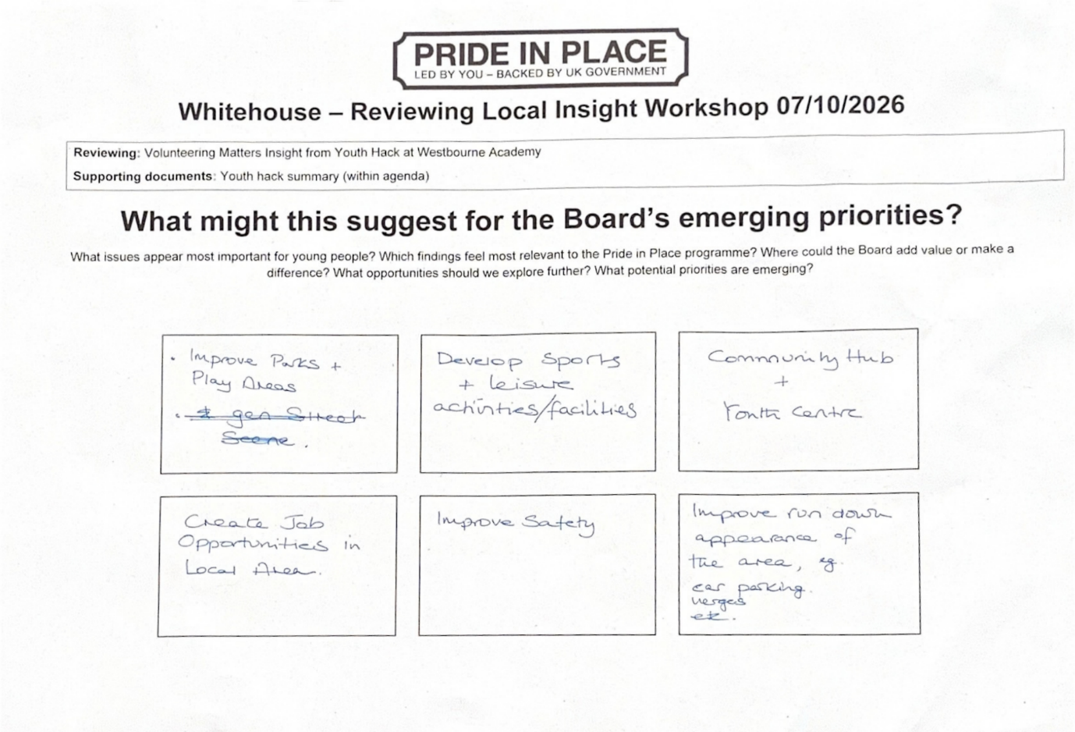
Review of feedback from local residents – residents survey conducted by Volunteering Matters
Discussion of resident survey responses revealed some pride in Whitehouse's parks and the local environment. However, concerns about crime, safety and the appearance of the physical environment featured prominently throughout the feedback. Issues raised included a lack of lighting, overgrown verges, the condition of parks, parking issues and an overarching desire for the neighbourhood to be more attractive and welcoming.

Through the resident survey, local residents had already suggested a number of potential solutions, including improved lighting, CCTV, park improvements and investment in community and youth facilities.

The group also reflected on the limitations of the current evidence base. With only 128 survey responses received from a community of more than 9,000 residents, Board Members felt the findings provide a useful starting point but are not yet representative of the wider community. There was strong support for further engagement, including more visible outreach, mobile engagement activities and work with local schools and community organisations to reach a broader cross-section of residents, particularly those whose voices may currently be underrepresented.

When considering emerging priorities, discussion focused on visual improvements to make the area more attractive, the provision of free-to-access activities, community hubs, youth facilities, safety, accessibility, employment, education and training opportunities.
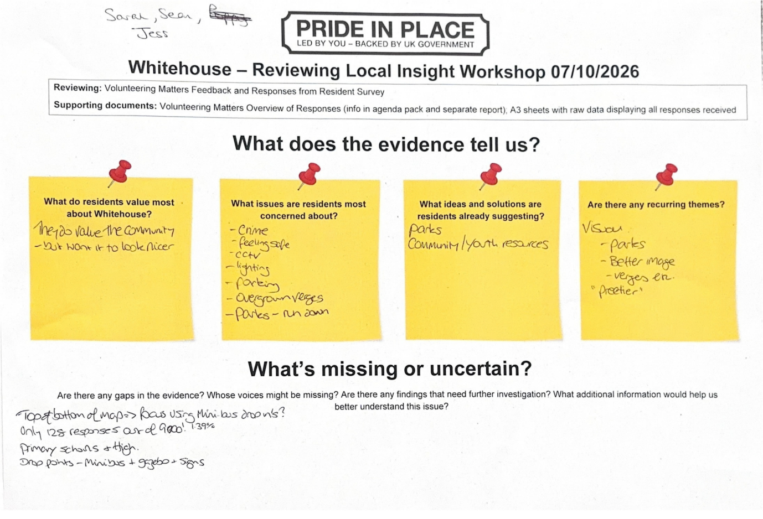
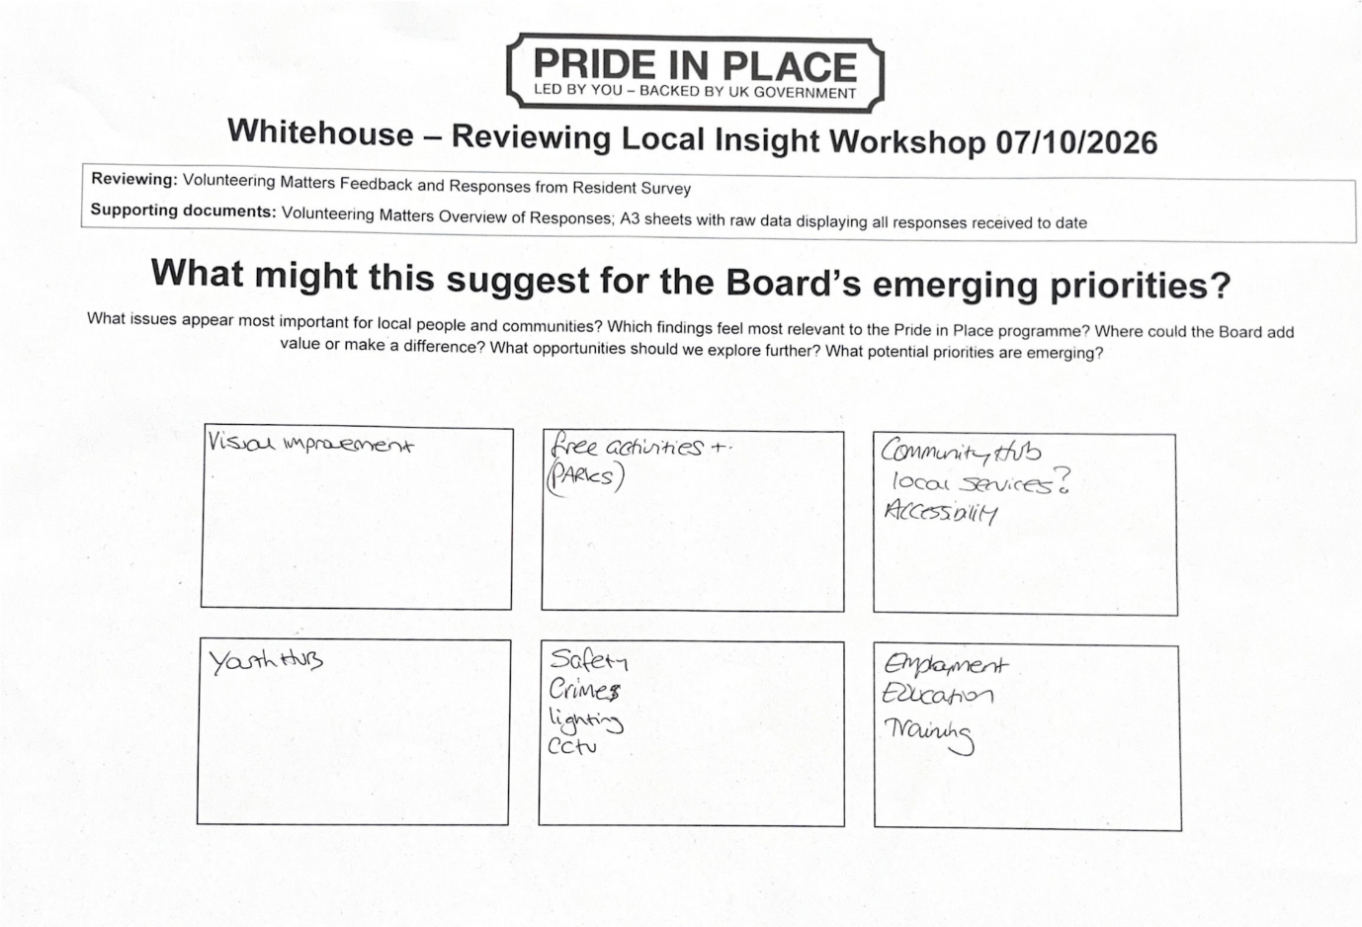

Review of local insight from Voluntary, Community, Faith and Social Enterprise (VCFSE) groups operating in Whitehouse – insight provided by Community Action Suffolk
Discussion of the feedback gathered from local organisations at the workshop delivered in August focused on the needs and challenges they are observing across Whitehouse. A recurring message was the lack of facilities and opportunities for young people, alongside a broader need for accessible places where residents can meet, socialise and participate in community life. Organisations also highlighted the value of local green spaces and recreational assets whilst identifying opportunities to make these spaces more inclusive and accessible.

Board Members discussed the demand for joined-up services and locally focused support. VCFSE organisations reported that residents often face practical barriers which limit participation, including cost, transport, digital exclusion and language barriers. There was also discussion around health inequalities and the importance of ensuring all residents can access local opportunities and services.

The group noted that older residents appeared underrepresented within some of the available evidence and felt further engagement with this demographic would be beneficial. Members were keen to ensure future priorities reflected the experiences and needs of residents of all ages.

Potential priorities identified through the discussion included creating or strengthening local community spaces, improving access to information and services, building on existing community assets and reducing barriers that prevent participation. There was strong support for exploring how community resources could be better connected through a joined-up local offer which combines physical and digital access to information and support.

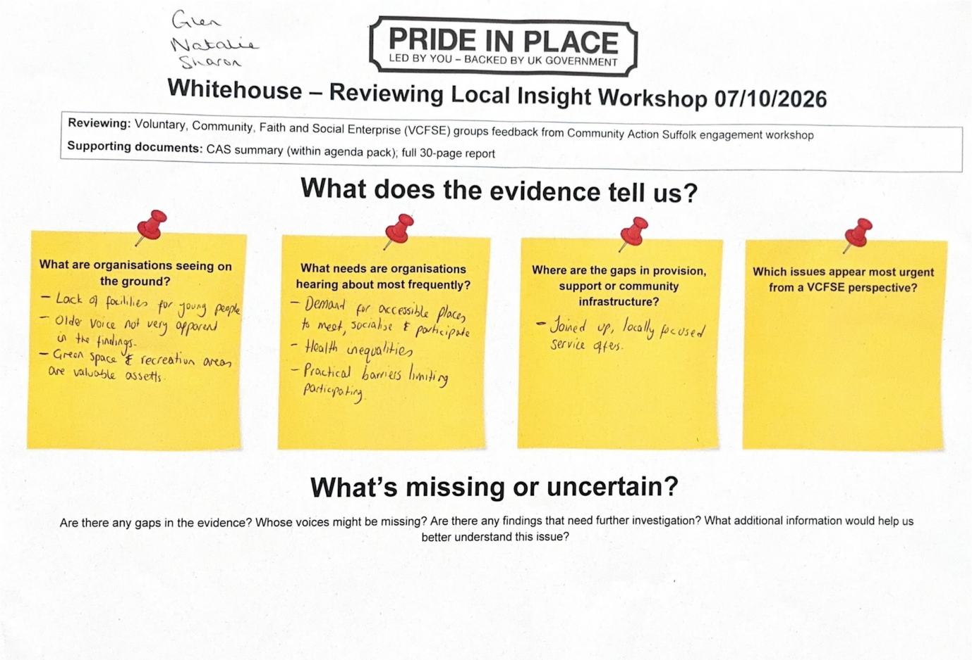
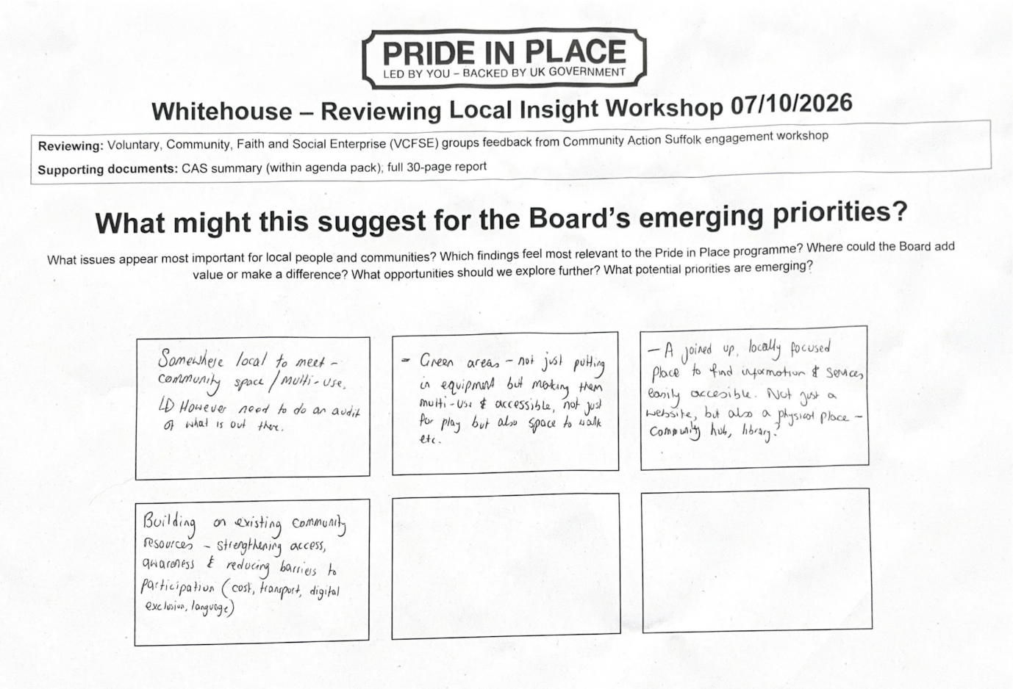

Emerging themes from workshop discussions
Across all four evidence sources and associated group discussions, several common themes emerged. These included the need for improved community facilities and gathering spaces, greater opportunities for young people, improvements to local parks, community safety, stronger access to information and services, and action to reduce barriers to participation. Board Members also highlighted the importance of undertaking further engagement to ensure the views of underrepresented groups are captured before priorities are finalised. In particular, it was felt that the needs and experiences of older residents were not coming through strongly in the evidence gathered to date, and that additional engagement may be needed to ensure their perspectives are reflected in the Board's future priorities.

Community spaces and community infrastructure
The need for accessible, multi-purpose community spaces emerged consistently across all discussions. Residents, young people and local organisations all identified a lack of places where people can meet, socialise and access activities or services locally. The concept of a community hub featured prominently, alongside discussions about making better use of existing facilities and assets. Board Members felt that stronger community infrastructure could support social connection, improve access to services and create opportunities for residents of all ages to participate in community life in Whitehouse.

Opportunities for young people
Young people were one of the most frequently discussed groups throughout the workshop. Evidence highlighted the need for additional activities, recreational facilities, sports provision and dedicated spaces for young people. There was also strong interest in improving pathways into employment, education and training. Board Members felt this represented a significant opportunity for the Pride in Place programme to make a meaningful contribution to the future aspirations and wellbeing of local young people.

Pride in Place and improving the local environment
Residents and young people both expressed a desire for visible improvements to the appearance of Whitehouse. Issues such as litter, overgrown verges, run-down spaces and the condition of parks and public areas were regularly mentioned. Residents also recognised existing green spaces as valuable local assets. This suggests an opportunity to focus on environmental improvements which both enhance neighbourhood appearance and encourage greater community pride and ownership.

Community safety and perceptions of safety
Crime and safety emerged repeatedly within resident and youth feedback. While many safety concerns are the remit of statutory agencies, Board Members recognised that perceptions of safety have a significant impact on quality of life and community confidence. Suggestions raised during discussions included improved lighting, improvements to the local parks, CCTV and activities that increase positive use of community/public spaces. Further engagement is required to better understand the nature of local safety concerns, explore any differences between perceptions and recorded issues, and identify areas where Pride in Place can make a positive contribution.

Access to opportunities, information and services
Across the workshop there was a clear desire for residents to be better connected to already existing local opportunities, services and community resources. Board Members discussed the value of a more joined-up approach to information sharing, alongside efforts to reduce barriers such as transport, cost, digital exclusion and lack of awareness.

Next steps
Following the workshop, Board Members agreed that further community engagement should be undertaken to explore the emerging themes in more detail and help determine which should be prioritised through the Whitehouse Pride in Place programme.
The workshop highlighted strong consistency across the different evidence sources, particularly around the importance of community facilities, opportunities for young people, improvements to local parks, community safety and better access to information and services. Whilst these themes provide a useful starting point, Board Members recognised the need to test these findings with a wider range of residents and stakeholders before final priorities are agreed. Particular attention should be given to engaging groups whose voices may currently be underrepresented, including older residents.
It should also be recognised that some issues raised during the workshop, particularly in relation to crime and community safety, sit within the responsibilities of statutory agencies and partner organisations. The role of Pride in Place is likely to focus on supporting complementary community-led initiatives, strengthening local assets and partnerships, and helping residents influence wider conversations.
The analysis from the workshop has been shared with Board members and provides a good evidence base to support the next phase of engagement and the development of priorities for the Stoke Park & Chantry Pride in Place Plan.

